# Core Concepts

Kubernetes Architecture

Master Node initialisation

Worker Nodes initialization - Worker1 & 2

Basic commands of Kubernetes

## Kubernetes Architecture

Master

API Server

Scheduler

Controller Manager

Cloud Controller Manager(CCM)

Etcd

Worker

Kubelet <-> Containerd

Kube-proxy

Pods - Containers - App running

Operator - Access API-Server for k8s calls - Create, Update, Read, Delete resources

K8s client - UI, API, CLI - kubectl

User - App users - Access App deployed in k8s

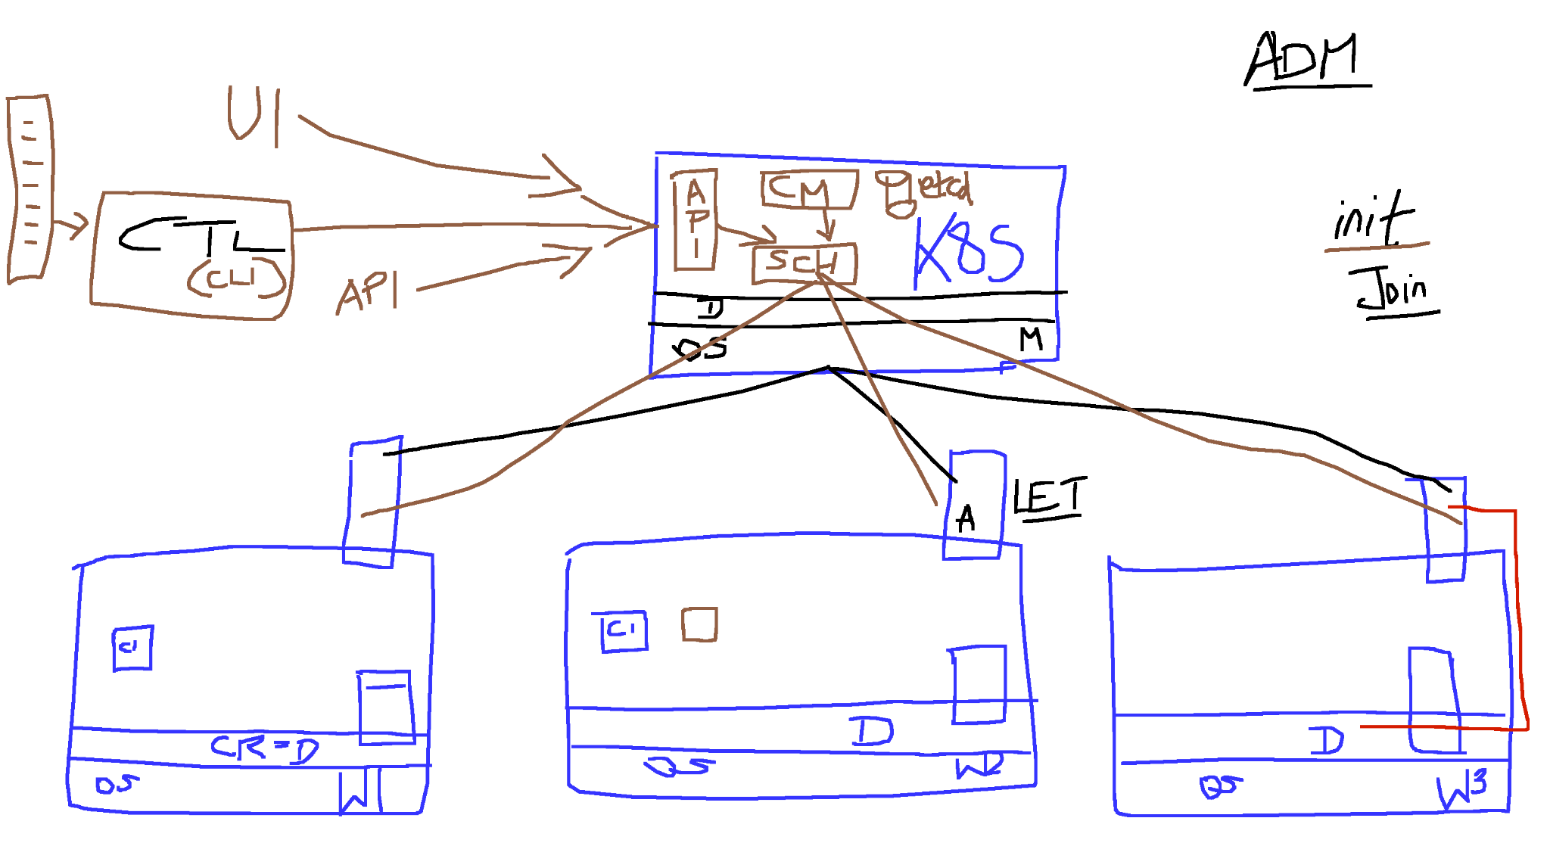

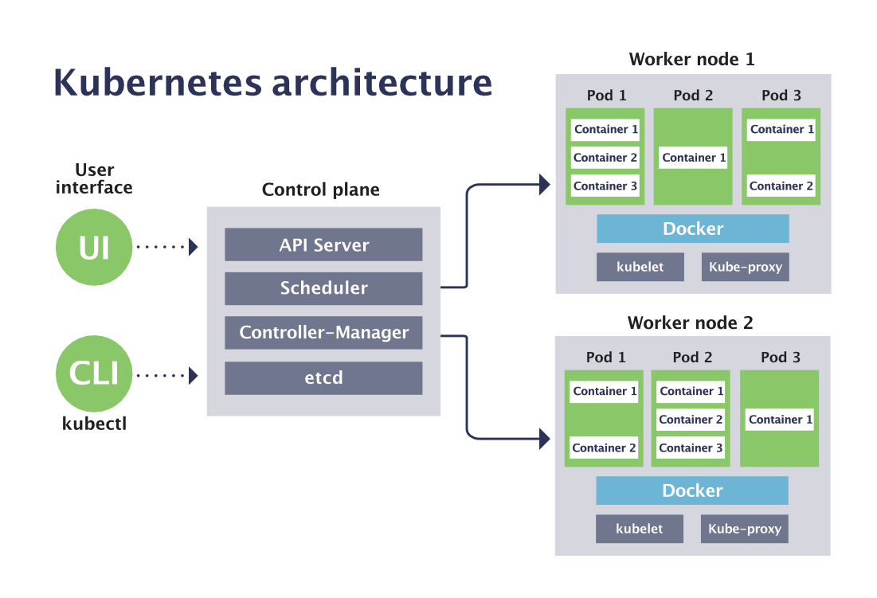

Node View - Many sizes of pods deployed

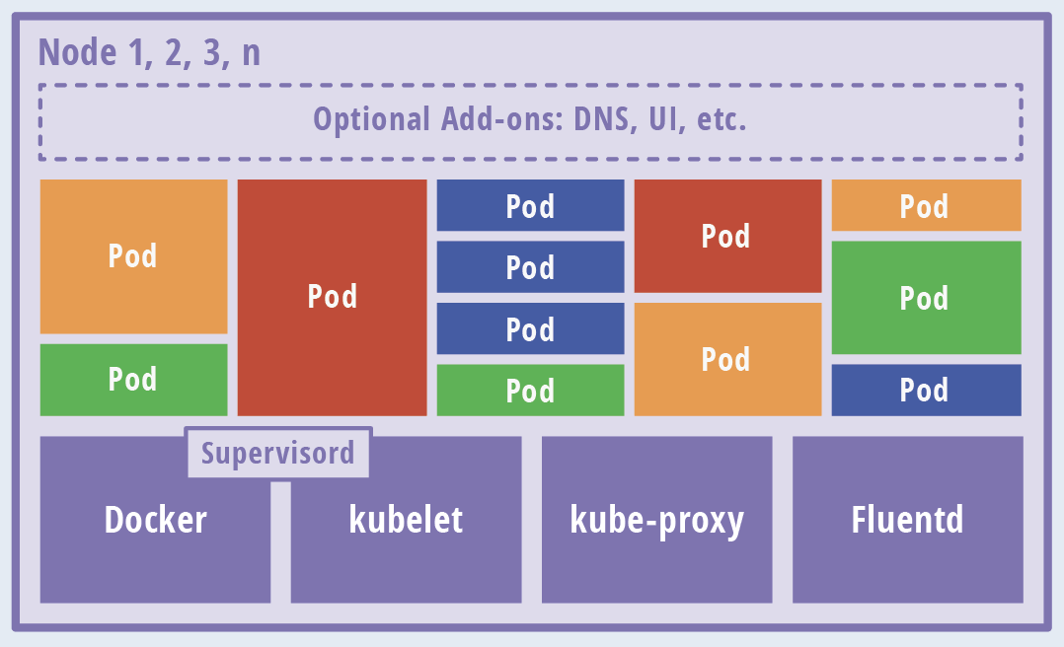

# Cluster Setup - v1.28

## Set Hostname

Master Node:

**sudo hostnamectl set-hostname master.example.com**

**exec bash**

Worker1 Node:

**sudo hostnamectl set-hostname worker-node-1.example.com**

**exec bash**

Worker2 Node:

**sudo hostnamectl set-hostname worker-node-2.example.com**

**exec bash**

## Master Node initialisation

sudo kubeadm init

* TODO: Copy kubeadm join command

mkdir -p $HOME/.kube

sudo cp -i /etc/kubernetes/admin.conf $HOME/.kube/config

sudo chown $(id -u):$(id -g) $HOME/.kube/config

cat ~/.kube/config

Install Container Network Interface (**CNI**)

kubectl delete -f <https://raw.githubusercontent.com/projectcalico/calico/v3.25.0/manifests/calico.yaml>

kubectl apply -f https://raw.githubusercontent.com/projectcalico/calico/v3.25.0/manifests/calico.yaml

Verification:

kubectl get nodes

NAME STATUS ROLES AGE VERSION

master.example.com Ready control-plane,master 64m v1.28.2

## 

## Worker Nodes initialization - Worker1 & 2

**DONT COPY AND PASTE:**

**[Swami’s Join command] sudo kubeadm join 172.31.58.71:6443 --token wh45u4.p1dy2fbkg7m49j2m \**

**--discovery-token-ca-cert-hash sha256:d6c81374c020437d30d356fb475be88a747b4c4e1de7b0701c21d11b0e0745e1**

**Note:** In case you need to find your unique token, run the command   
[MASTER] **sudo kubeadm token create --print-join-command**

labsuser@master:~$ kubectl get nodes

NAME STATUS ROLES AGE VERSION

master Ready control-plane,master 75m v1.28.2

worker-node-1.example.com Ready <none> 72s v1.28.2

worker-node-2.example.com Ready <none> 52s v1.28.2

# Basic commands of Kubernetes

kubectl get nodes

kubectl get nodes -o wide

kubectl describe node worker-node-1.example.com

kubectl get pods -n kube-system